**SPRINT 4**

**EXPORT THE ANALYTICS**

|  |  |
| --- | --- |
| DATE | 16-11-2022 |
| TEAM ID | PNT2022TMID24269 |
| PROJECT NAME | Estimate The Crop Yield Using Data Analytics |

Finally, it's to share your work either through email/link/pdf to showcase your works to others.

STEP 1:

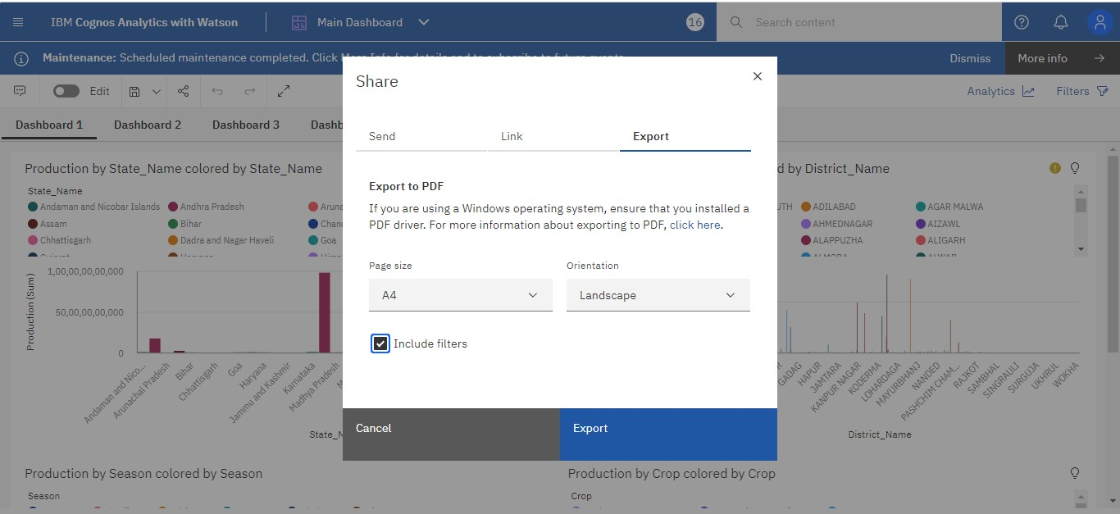

STEP 2:

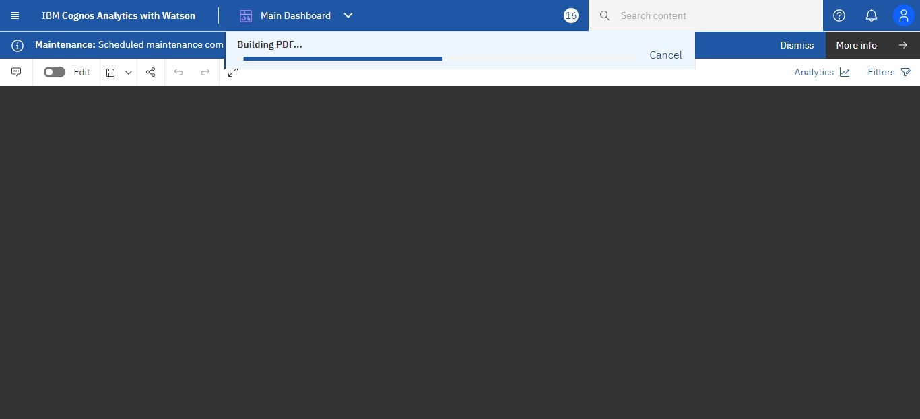

STEP 3:

